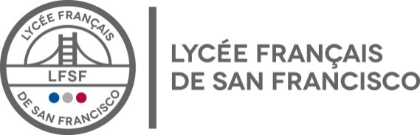

FINANCIAL AID REQUEST 2020-2021

Before completing the form, save it on your computer. You may give your answers in French

● Parent A Name
● Parent B Name
● Other parent Name
● Marital Status | ☐ Married
 | ☐ Separated/divorced applying together / One PFS was completed
 | ☐ Separated/divorced applying separately / Both parents have files a PFS
 | ☐ Single parent applying alone. Explain why:
Percentage of tuition paid by single parent or separated parents:
☐ Single Parent 100% ☐ Other Mother % - Father %
● If French (parents and/or children):
● We plan to apply for a French government scholarship in February 2019: ☐Yes ☐ No If no explain:
● We received income from 1 country only in 2018 and 2019: ☐ Yes ☐ No
● We received income in multiple countries in 18-19; we indicated all the income in our PFS: ☐Yes ☐ No
● We have had a recent change in our employment situation ☐ Yes ☐ No
If yes explain: (Include employment dates):
● We are moving to the USA in 2020-2021? ☐Yes ☐ No
● Start date of new employment in the USA:
● Why do you need financial help from LFSF? Be as specific as you can:
● Any other information you would like the committee to take in consideration while examining your
application:
● I am uploading in my SSS Application all the documents required and applicable to my situation:
☐Yes ☐ No If not explain:

